**HOW TO STORE FOOD IN A STAINLESS STEEL POTS**

*Maybe everyone has at least one pot made of stainless steel. When cooking with these stainless steel pots, do you find the food cooked faster and better? Is it easier to clean stainless steel pots? If the answer is "No", please read this article to know how to use and preserve stainless steel pot properly and effectively.*

**Choose the size of stainless steel cooker suitable for the kitchen**

*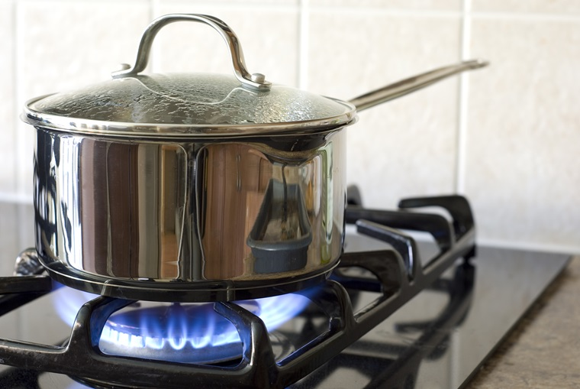  
Choose medium sized stainless steel cookers for cooking to save energy*

For efficient, energy-efficient cooking, you should choose the right size for the fire ring, the heat ring of the gas stove, the electric stove. Put balance pots and pans on the stove, do not tilt, skew, adjust the concentrated flame at the bottom of the pot, radiant heat helps the food to ripen quickly, reduce the maximum energy consumption. During the cooking process, you should cover the lid to help save energy, cooking time and, moreover, retain many of the nutrients in the food.

**Understand the characteristics of stainless steel and use the right stainless steel pot for the right use**

*Should choose 3-bottom stainless steel pot (thick bottom) to cook more dishes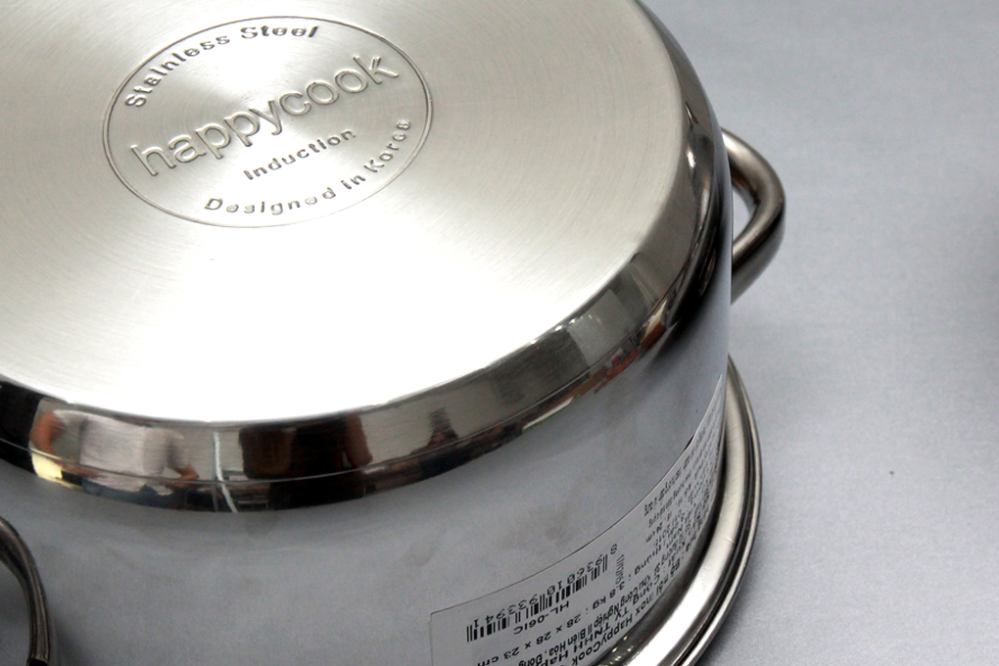*

Also the disadvantages of stainless steel pots are irregular heat. If it is a bottom pot, thin bottom is easy to burn food, only suitable for boiling, cooking soup, not suitable for frying. If you want to fry, stir-fry, or cook food, you should use 3 or more pots, because between 2 stainless steel bottom layers are aluminum, help the pot absorb more heat, even heat transfer, cooking better.

**Do not cook stainless steel pots without food on the kitchen for too long**

Absolutely do not let stainless steel pots have no food or just have cooking oil inside the stove for too long, especially when you turn the big fire, high temperature. Doing so will cause the bottom of the pot and pan to become yellow, deformed due to high temperature, reduced durability, difficult to clean after use.  
**Reduce processing of too acidic dishes, too salty in stainless steel pots**

You should not or limit cooking foods that are too salty, too sour in stainless steel pots, to salt, sour foods, high acidity in stainless steel pots overnight, will easily corrode stainless steel materials of cookware. At the same time, the dish cooked with that pot is also not good for your family's health

**Let the stainless steel pot cool and then cleadddn**

Do not pour cold water into a hot stainless steel pot, avoid causing heat shock, making the cookware stain, difficult to clean. Let the cookware cool before pouring it in to clean it.

**Do not use sharp objects to clean the pot**

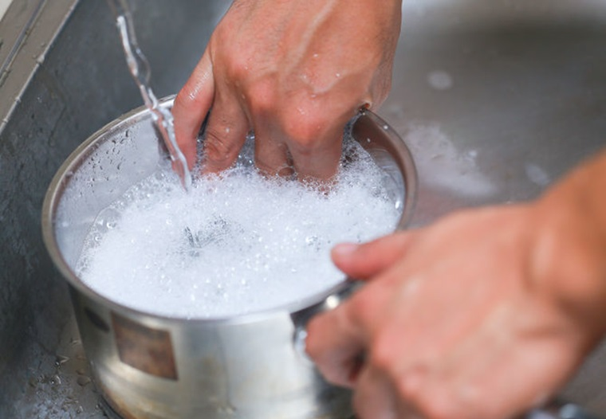  
*Do not use chlorine cleaners to clean the pot, use a mild detergent*

With stubborn stains, you do not use sharp objects to clean, will make the stainless steel pot scratched, lose the shiny look often available. You should soak the pot in warm water for soft stains, expand, the cleaning process will be easier. Do not use chlorine cleaners, this will quickly damage the surface of the pot, so use household dishwashing liquid such as Sunlight, My Hao, clean with a soft cloth, sponge washing pads, do not use hard dishwashing pieces. With the yellow burns on the bottom of the pot, take a soft towel soaked through the vinegar or lemon juice and then wipe it in a circle, the burn will quickly disappear.

**Some other usage and preservation tips**

When you first buy it, you want to clean the labels and stamps on the stainless steel pot, use a soft cloth to absorb a little dishwashing liquid and clean the labels and stamps. Do not use sharp objects to scratch it will scratch the surface of your pot.

When you first use the stainless steel pot, you should add water and add some vinegar or lemon juice to the cookware and boil. After processing food, the food will be delicious and the product will have better durability.

Using cooking utensils made of wood, plastic, silicon for processing, do not use sharp and sharp objects to fry and cook, it will quickly damage the stainless steel material of the product.

After cooking, you should clean the pot immediately, use a dry cloth to clean the water before storing, put in a dry place, do not pile too many things to avoid scratching.